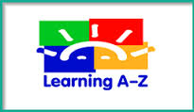
Learning A-Z Products Grades TK-5
Reading A-Z
Raz-Kids
Writing A-Z
Vocabulary A-Z
https://www.learninga-z.com/index.html

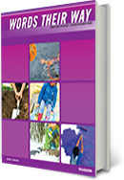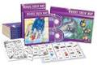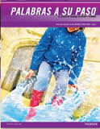
Grades K-5 Words Their Way
Bilingual Alternative Program: Palabras a Su Paso
http://www.pearsonschool.com/index.cfm?locator=PSZw84

Grades K-6 Spelling City
https://www.spellingcity.com/



Being a Writer K-5
https://www.collaborativeclassroom.org/being-a-writer
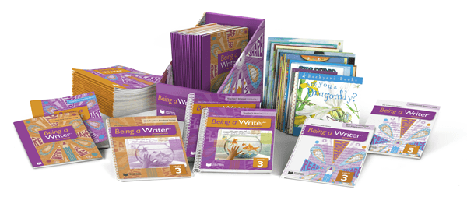

Core Knowledge Language Arts Kits (Listening and Learning Strand, Skills Strand) Grades K-5
amplify core-knowledge-language-arts - how-it-works

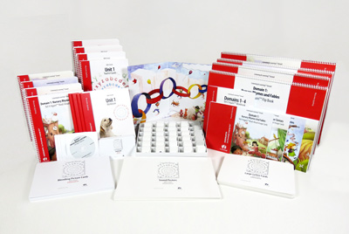

Scholastic News Grades TK-3
http://magazines.scholastic.com/
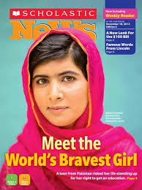

NewsELA Grades 4-12
NewsELA



